# CANDIDATE’S DECLARATION

We, hereby declare that the work presented in this project entitled “TRIP PLANNER” in the partial fulfillment of the requirements for the award of the Degree of Bachelor of Technology in Computer Science & Engineering at JECRC University, Jaipur is an authentic work of our own.

We have not submitted the matter embodied in this project work anywhere for the award of degree of Bachelor of Technology in Computer Science & Engineering.

**Student Name : PRADHYUMAN SINGH BHATI (21BCON309)**

**RANVIR TAILOR (21BCON546)**

**APURAV GARG (21BCON343)**

**Date: 16TH May 2024**

**Place: JECRC University, Jaipur, Rajasthan**

BONAFIDE CERTIFICATE

This is to certify that the project entitled "TRIP PLANNER" is the bonafide work carried out by Ranvir Tailor, Apurav Garg and Pradhyuman Singh Bhati students of B.Tech. in Computer Science & Engineering at JECRC University, during the year 2023-24 in partial fulfillment of the requirements for the award of the Degree of Bachelor of Technology in Computer Science & Engineering and the project has not formed the basis for the award previously of any degree, diploma, fellowship, or any other similar title.

**Name of Guide : Dr. Dushyant Singh**

**Designation : Assistant Professor**

**Place: Jaipur, Rajasthan**

**Date: 16TH May 2024**

**VISION OF CSE DEPARTMENT**

To become renowned Centre of excellence in computer science and engineering and make competent engineers and professionals with high ethical values prepared for lifelong learning.

**MISSION OF CSE DEPARTMENT**

1. To impart outcome based education for emerging technologies in the field of computer science and engineering.
2. To provide opportunities for interaction between academia and industry.
3. To provide platform for lifelong learning by accepting the change in technologies.
4. To develop aptitude of fulfilling social responsibilities.

**PROGRAM OUTCOMES (POs)**

1. **Engineering knowledge:** Apply the knowledge of mathematics, science, engineering fundamentals, and an engineering specialization to the solution of complex engineering problems.
2. **Problem analysis**: Identify, formulate, research literature, and analyze complex engineering problems reaching substantiated conclusions using first principles of mathematics, natural sciences, and engineering sciences.
3. **Design/development of solutions**: Design solutions for complex engineering problems and design system components or processes that meet the specified needs with appropriate consideration for the public health and safety, and the cultural, societal, and environmental considerations.
4. **Conduct investigations of complex problems**: Use research-based knowledge and research methods including design of experiments, analysis and interpretation of data, and synthesis of the information to provide valid conclusions.
5. **Modern tool usage**: Create, select, and apply appropriate techniques, resources, and modern engineering and IT tools including prediction and modeling to complex engineering activities with an understanding of the limitations.
6. **The engineer and society**: Apply reasoning informed by the contextual knowledge to assess societal, health, safety, legal and cultural issues and the consequent responsibilities relevant to the professional engineering practice.
7. **Environment and sustainability**: Understand the impact of the professional engineering solutions in societal and environmental contexts, and demonstrate the knowledge of, and need for sustainable development.
8. **Ethics**: Apply ethical principles and commit to professional ethics and responsibilities and norms of the engineering practice.
9. **Individual and team work**: Function effectively as an individual, and as a member or leader in diverse teams, and in multidisciplinary settings.
10. **Communication**: Communicate effectively on complex engineering activities with the engineering community and with society at large, such as, being able to comprehend and write effective reports and design documentation, make effective presentations, and give and receive clear instructions.
11. **Project management and finance**: Demonstrate knowledge and understanding of the engineering and management principles and apply these to one’s own work, as a member and leader in a team, to manage projects and in multidisciplinary environments.
12. **Life-long learning**: Recognize the need for, and have the preparation and ability to engage in independent and life-long learning in the broadest context of technological change.

**PROGRAM EDUCATIONAL OBJECTIVES (PEOs)**

The PEOs of the B.Tech (CSE) program are:

**PEO1**:  To provide students with the fundamentals of Engineering Sciences with more emphasis in computer science and engineering by way of analyzing and exploiting engineering challenges.

**PEO2:** To train students with good scientific and engineering knowledge so as to comprehend, analyze, design, and create novel products and solutions for the real life problems.

**PEO3**: To inculcate professional and ethical attitude, effective communication skills, teamwork skills, multidisciplinary approach, entrepreneurial thinking and an ability to relate engineering issues with social issues.

**PEO4:** To provide students with an academic environment aware of excellence, leadership, written ethical codes and guidelines, and the self-motivated life-long learning needed for a successful professional career.

**PEO5**: To prepare students to excel in Industry and Higher education by educating Students along with High moral values and Knowledge.

**PROGRAM SPECIFIC OUTCOMES (PSOs)**

**PSO1:** Ability to interpret and analyze network specific and cyber security issues in real world environment.

**PSO2:** Ability to design and develop Mobile and Web-based applications under realistic constraints.

**COURSE OUTCOMES (COs)**

On completion of project Graduates will be able to-

* CO1: Gather, organize, summarize and interpret technical literature with the purpose of formulating a project proposal.
* CO2: Design/Develop the solution using latest technologies and communicate via modern tools.
* CO3 Understand and develop the professional, social ethics, and team management principles.

**MAPPING: CO’s & PO’s**

|  |  |  |  |  |  |  |  |  |  |  |  |  |  |  |  |
| --- | --- | --- | --- | --- | --- | --- | --- | --- | --- | --- | --- | --- | --- | --- | --- |
| **Subject** | **Code** | **L/T/P** | **CO** | **PO1** | **PO2** | **PO3** | **PO4** | **PO5** | **PO6** | **PO7** | **PO8** | **PO9** | **PO10** | **PO11** | **PO12** |
| **Project** | 8CS7-50 | P | Graduates will be able to: gather, organize, summarize and interpret technical literature with the purpose of formulating a project proposal. | 3 | 3 | 3 | 2 | 2 | 2 | 1 | 2 | 1 | 2 | 2 | 3 |
| P | Graduates will be able to: Design/Develop the solution using latest technologies and communicate via modern tools. | 3 | 3 | 3 | 2 | 2 | 2 | 1 | 2 | 2 | 2 | 2 | 3 |
| P | Graduates will be able to: Understand and develop the professional, social ethics, and team management principles. | 3 | 3 | 3 | 2 | 2 | 2 | 1 | 2 | 2 | 2 | 2 | 3 |

**ACKNOWLEDGEMENT**

We wish to express our deep sense of gratitude to our Project Guide Dr. Dushyant Singh, JECRC University, Jaipur for guiding us from the inception till the completion of the project. We sincerely acknowledge him for giving his valuable guidance, support for literature survey, critical reviews and comments for our Project.

We would like to first of all express our thanks to **Mr. Arpit Agrawal** Director of JECRC, for providing us such a great infrastructure and environment for our overall development.

Words are inadequate in offering our thanks to HOD **Mrs. Bhavna Sharma ,** HOD of CSE department, for consistent encouragement and support for shaping our project in the presentable form.

We also like to express our thanks to all supporting CSE faculty members who have been a constant source of encouragement for successful completion of the project.

Also, our warm thanks to **JECRC University**, who provided us this opportunity to carryout, this prestigious Project and enhance our learning in various technical fields.

**Student**

**Name - PRADHYUMAN SINGH BHATI (21BCON309)**

**RANVIR TAILOR (21BCON546)**

**APURAV GARG (21BCON343)**

**ABSTRACT**

Planning a trip can be a daunting task due to the abundance of options and information available. Existing trip planner applications often lack user-friendliness and fail to provide personalized recommendations, resulting in user dissatisfaction.

This report presents the development and implementation of a trip planner website designed to serve as a comprehensive travel guide for tourists. The website aims to assist travelers in discovering the best attractions and activities at various tourist destinations. Through meticulous research and innovative design, the platform offers personalized itineraries, highlighting unique experiences tailored to individual preferences and interests.

The key applications of the website are as follows:-

1. Destination Discovery: Users can explore a wide range of tourist destinations, uncovering hidden gems and lesser-known attractions through curated recommendations and comprehensive destination guides.
2. Simple Registration and Profile Setup: Users can create accounts quickly with minimal required information, allowing them to personalize their experience and save preferences for future use.
3. Sustainable Tourism Practices: Through partnerships with local experts and organizations, the platform promotes responsible and sustainable tourism practices, empowering travelers to make informed choices that minimize their environmental impact and support local communities.
4. Clear and Concise Information: Destination guides, activity listings, and other content are presented in a clear and concise manner, with relevant details and highlights prominently displayed, enabling users to make informed decisions quickly.

**LIST OF FIGURES**

* + Registration page
  + Home page
  + Code 1
  + Code 2

**TABLE OF CONTENTS**

**Candidates Declaration------------------------------------------------------------------------- i**

**Bonafide Certificate------------------------------------------------------------------------------ ii**

**Vision and Mission------------------------------------------------------------------------------- iii**

**Program Outcomes (POs)----------------------------------------------------------------------- iv**

**Program Education Objectives (PEOs) ------------------------------------------------------ v**

**Program Specific Outcomes (PSOs)----------------------------------------------------------- v**

**Course Outcomes (COs)------------------------------------------------------------------------- vi**

**Mapping: COs and POs-------------------------------------------------------------------------- vi**

**Acknowledgement--------------------------------------------------------------------------------- vii**

**Abstract---------------------------------------------------------------------------------------------- viii**

**List of Figures--------------------------------------------------------------------------------------- ix**

**1. INTRODUCTION------------------------------------------------------------------------------ 1**

* 1. Purpose --------------------------------------------------------------------------------------- 1
  2. Project Scope--------------------------------------------------------------------------------- 3
  3. Document Convention ---------------------------------------------------------------------- 5

**2. REQUIREMENT ANALYSIS--------------------------------------------------------------- 6**

2.1 Hardware Requirement--------------------------------------------------------------------- 6

2.2 Software Requirement ---------------------------------------------------------------------- 9

2.3 Functional Requirement--------------------------------------------------------------------- 10

2.4 Non Functional Requirements ------------------------------------------------------------ 11

**3. SYSTEM DESIGN------------------------------------------------------------------------------- 12**

3.1 Use Case Diagram--------------------------------------------------------------------------- 12

**4. SCREEN SHOTS-------------------------------------------------------------------------------- 13**

**5. TESTING ----------------------------------------------------------------------------------------- 17**

**6. LIMITATIONS OF PROJECT--------------------------------------------------------------- 19**

**7. FUTURE SCOPE OF PROJECT------------------------------------------------------------- 21**

**8. REFERENCES----------------------------------------------------------------------------------- 24**

**1 .** **INTRODUCTION**

**1.1 PURPOSE**

The purpose of the trip planner website project is to revolutionize the way individuals plan, experience, and share their travels. At its core, the project aims to address the inherent complexities and challenges associated with travel planning by providing users with a centralized, user-friendly platform that offers personalized recommendations, curated experiences, and valuable insights.

By leveraging innovative technology and design principles, the project seeks to create an intuitive and immersive digital environment where users can seamlessly explore a vast array of destinations, activities, and accommodations. The website tailors its recommendations to match the unique preferences, interests, and constraints of each traveler, ensuring that every trip is crafted to perfection.

Moreover, the project is driven by a broader mission to inspire curiosity, foster connection, and promote sustainability within the travel community. By showcasing popular destinations, highlighting local culture and heritage, and advocating for responsible tourism practices, the website encourages users to step off the beaten path and engage with the world in meaningful and authentic ways. It aims to create a environment which is experienced ,personalized and widely excepted by the people.

At its essence, the project seeks to address the evolving needs and desires of modern travelers who crave experiences that are not only memorable but also meaningful and immersive. In today's fast-paced world, where time is a precious commodity and choice overload is a common challenge, the trip planner website project aims to simplify the travel planning process while maximizing the quality and depth of the travel experience.

It aims to address various other needs and objectives within the realm of travel and tourism:-

1. Facilitating Seamless Travel Planning: The primary purpose of the project is to simplify and streamline the travel planning process for individuals and groups. By offering a centralized platform with comprehensive destination information, activity suggestions, food and accommodation information, the website aims to empower users to plan their trips efficiently and effectively.
2. Enhancing User Experience: The project seeks to enhance the overall travel experience for users by providing them with personalized recommendations, insider tips, and curated experiences that align with their interests and preferences. By offering a user-friendly interface, intuitive navigation, and helpful support resources, the website aims to make the journey from planning to execution as smooth and enjoyable as possible.
3. Promoting Exploration and Discovery: Another purpose of the project is to inspire and encourage travelers to explore new destinations and discover hidden gems that they may not have otherwise encountered. By highlighting unique attractions, off-the-beaten-path experiences, and local insights, the website aims to foster a sense of curiosity and adventure among its users.

Overall, the purpose of the trip planner website project is to serve as a comprehensive and user-centric tool that empowers travelers to embark on memorable journeys, discover new horizons. Whether it's a solo adventure, a family vacation, or a group excursion, the website aims to serve as a trusted companion, guiding users every step of the way as they navigate the vast and wondrous landscape of travel and forge meaningful connections with the world around them.

* 1. **PROJECT SCOPE**

The scope of this project report encompasses the comprehensive development and evaluation of a Trip Planner system designed to serve as a personalized trip guide, offering recommendations for optimal food, accommodation, and attractions. The report will delve into the technical implementation, functionality, user interface design and potential future enhancements of the Trip Planner system. The project will begin with an introduction elucidating the rationale behind the creation of the Trip Planner system, outlining its objectives, and highlighting its significance in modern travel planning.

The technical implementation section of the project report will focus on the development aspects of the Trip Planner system, detailing the software architecture, programming languages, frameworks, and methodologies utilized in its creation. Without reliance on external APIs or databases, the scope will emphasize internal system design and functionality. The technical implementation section of the project report will provide a detailed insight into the development aspects of the Trip Planner system, focusing on software architecture, programming languages, frameworks, system integration, deployment, scalability, security, testing, performance optimization, documentation, and maintenance.

Functional requirements will be meticulously detailed, delineating the various features and capabilities of the Trip Planner system. Use cases will be presented to illustrate how users interact with the system to plan their trips effectively, while requirement specifications will outline the functionality of each module within the system.

System testing procedures will be detailed, encompassing methodologies employed for validating the Trip Planner system's functionality, reliability, and performance. Test scenarios and cases will be presented, along with the results of testing and evaluation.

Finally, the report will discuss potential future enhancements and extensions of the Trip Planner system, exploring avenues for integrating emerging technologies and scaling the system to accommodate a larger user base. It will discuss what new features can be added which can help the users simplify their trip it includes itenary creations and the increase in number of places where the web application can serve.

In conclusion, this project report will provide a comprehensive overview of the development, implementation, and evaluation of the Trip Planner system, offering insights into its functionality, usability, and potential impact on the field of travel planning.

**1.3** **DOCUMENT CONVENTION**

To maintain consistency and clarity throughout the project documentation, the following conventions will be adhered to:

Formatting: All documents will follow a standardized format, including headings, subheadings, font styles, and page layouts.

Version Control: Documents will be version-controlled to track changes, revisions, and updates effectively

Naming Conventions: Clear and descriptive names will be used for documents, sections, and files to facilitate easy navigation and retrieval. In files name .html file, .css file and .js file these types will be included.

Documentation Standards: The documentation will comply with industry standards and best practices, ensuring readability, completeness, and accuracy.

Review and Approval Process: All documents will undergo a review and approval process involving relevant stakeholders to ensure quality and alignment with project objectives.

Adhering to terms and services: It is important to adhere to the documentation as it helps in maintaining a systematic and efficient way to provide services for users. It is also mandatory for users to follow all guidelines in any legal case and while using the application.

By including these document conventions in the report, stakeholders and contributors will gain insight into the project's organizational structure, coding standards, testing practices, and documentation guidelines, thereby fostering a cohesive and well-managed development process.

.

1. **REQUIREMENT ANALYSIS**

**2.1 HARDWARE REQUIREMENT**

The development of a Trip planning website, herein referred to as “TRIP PLANNER”, demands a meticulous approach to specifying the hardware requirements. This document outlines the hardware specifications needed to efficiently design, develop, test, and deploy Trip planner; a web platform aimed at providing useful information about different destinations to the users. The website will be developed using HTML, CSS, JavaScript, and MySQL, necessitating a hardware setup that supports these technologies efficiently.

**1. Development Environment Hardware Requirements**

The development of Trip planner requires a hardware environment that can support the installation and operation of various development tools, languages and softwares. Below are the detailed specifications:

Workstation Specifications:

- Processor: Intel Core i5-11400 / AMD Ryzen 5 3600 or higher. A multi-core processor is recommended for faster compilation times and smoother performance during development.

- Memory (RAM): 8GB DDR4 or higher. Adequate RAM is crucial for running multiple applications simultaneously, such as code editors, browsers, database servers, and other development tools.

Storage:

- SSD (Solid State Drive) with a minimum of 512GB. SSDs offer faster read/write speeds, which significantly reduce project load times and database access times.

- It is also advisable to have an external backup solution (either an external HDD or cloud storage) for regular backups of the project and database.

Graphics Card:

Integrated graphics (Intel UHD Graphics 630 or AMD equivalent) are sufficient. However, for UI/UX design tasks, a dedicated graphics card (NVIDIA GTX 1050 or AMD equivalent) may be beneficial.

Network Interface:

Gigabit Ethernet and/or Wi-Fi 5/6 for internet access and local network connectivity.

Display:

Full HD (1920x1080) monitor, 21-inch or larger, for efficient coding and design work. A dual-monitor setup is recommended for increased productivity.

Network Interface:

Gigabit Ethernet for reliable local network connectivity.

Production Environment Hardware Requirements:

- Processor: Intel Xeon Gold / AMD EPYC or higher, optimized for high availability and parallel processing capabilities.

- Memory (RAM): 32GB DDR4 or higher, to accommodate high user loads and in-memory operations .

- Storage:

* Primary: 512 GB SSD for the operating system, web server, and application files, ensuring quick access times.
* Secondary: 1TB HDD or more for database storage, providing ample space for user data, project files, and backups.

- Network Interface: 150Mbps dedicated internet connection or higher for handling incoming traffic without bottlenecks.

Additional Hardware Components -

- Uninterruptible Power Supply (UPS): For both development and production environments, a UPS ensures the hardware remains operational during short power outages, preventing data loss.

- Networking Equipment: High-quality routers and switches to support the internal network infrastructure, ensuring reliable connectivity.

**2.2 Software requirements**

**Development:-**

HTML (Hypertext Markup Language): As the backbone of the website, HTML5 will be employed to structure the content on the web pages, ensuring semantic accuracy and compliance with web standards.

CSS (Cascading Style Sheets): CSS3 will be used for styling the HTML content, ensuring the website is visually appealing and provides a responsive user interface adaptable to various devices (desktops, tablets, and smartphones). In simpler terms, CSS defines how HTML elements are displayed on a web page or in other media.

JavaScript: To make the website interactive and enhance user experience, JavaScript will be utilized. Features such as form validations, dynamic content loading, and animations will be implemented using JavaScript and AJAX for asynchronous web page updates.

**Development Environment and Tools**

Visual Studio Code: As the primary integrated development environment (IDE), Visual Studio Code will be used for coding, supported by extensions for HTML, CSS, and JavaScript linting and debugging. Git: For version control, Git will be employed to track and manage changes to the project codebase, facilitating collaboration among team members.

Figma: It will be used for designing the UI/UX for the web application which can be later converted into the CSS code accordingly. It provides various features to improve design of the application and collaborative environment for the team members.

**2.3 Functional Requirement**

The functional services which are provides in the project are as follows:-

* **User Registration**:
* Users should be able to register for an account with the Trip Planner system.
* Registered users should be able to log in securely using their credentials.
* **Search Functionality:**
* Users should be able to search for destinations based on various criteria such as location, activities, or interests.
* Search results should display relevant information about destinations, including descriptions, ratings, and user reviews.
* **Restaurant Recommendations :**
* The system should recommend restaurants and dining options based on user preferences, cuisine preferences, and location.
* Users should be able to view restaurant details, ratings, and maps of the hotel.

These functional requirements outline the core features and capabilities of the Trip Planner system, enabling users to efficiently plan, organize, and enjoy their travel experiences.

**2.4 NON FUNCTIONAL REQUIREMENT**

* **Usability:**
* The user interface should be intuitive, easy to navigate, and accessible to users of all skill levels.
* Design elements such as color contrast, font size, and interactive elements should adhere to accessibility guidelines to accommodate users with disabilities.
* **Performance:**
* The system should load quickly and respond to user interactions promptly, even under peak load conditions.
* Response times for search queries, recommendations, and booking transactions should be minimal to ensure a smooth user experience.
* **Maintainability:**
* The Codebase should be well-organized, modular, and documented to facilitate ease of maintenance and future enhancements.
* Version control practices should be followed to track changes and collaborate effectively with team members.

**3. SYSTEM DESIGN**

**3.1.Use Case Diagram:**

**4. SCREENSHOT**

* 1. **Registration Page:**

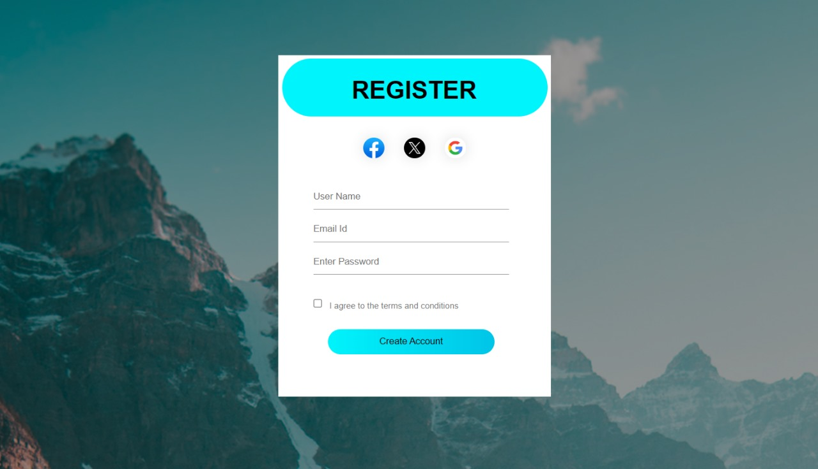

* 1. **Home Page:**

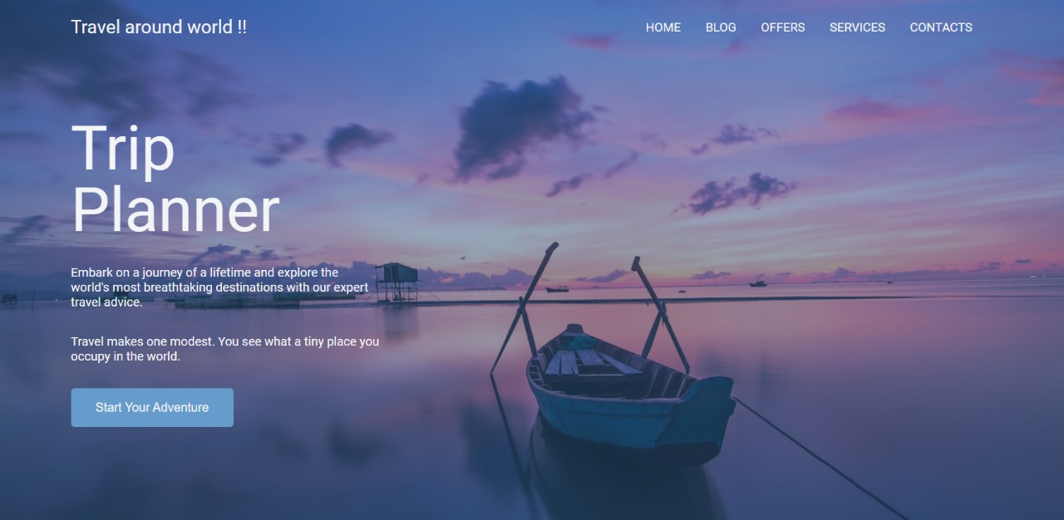

* 1. **Code:**

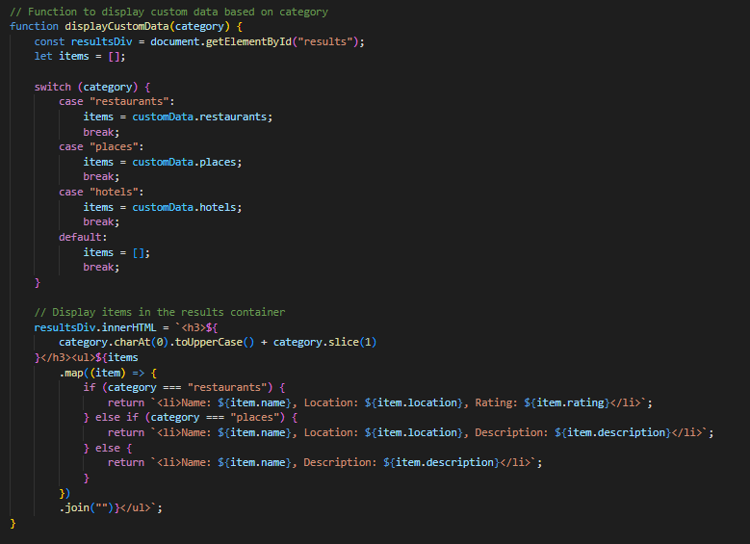

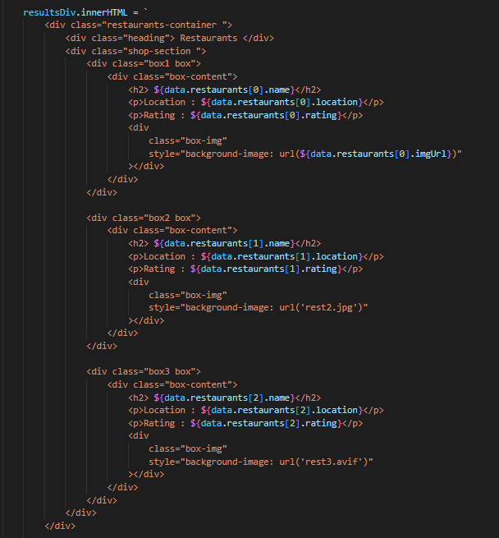

1. **TESTING**

In the realm of software development, testing is an essential phase that ensures the application's functionality, usability, reliability, and security before it is made available to end-users. This report outlines the testing methodologies, tools, and procedures employed to assess our Trip planner website project; a platform designed to connect freelancers with clients. Developed using HTML, CSS and JavaScript, our website requires rigorous testing to guarantee a seamless, secure, and efficient user experience.

**Testing Methodologies**

**1. Unit Testing**

Unit testing involves verifying the smallest testable parts of the application, known as units. For our project, units correspond to functions and methods in the JavaScript functions .

**2. Integration Testing**

Integration testing assesses the cooperation between different modules of the website. The focus is on the data flow and interaction between HTML forms, CSS styling and JavaScript validations for automating the interaction with web browsers, ensuring that the integrated components function collectively without issues.

**3. System Testing**

System testing evaluates the system's compliance with the specified requirements. It is a holistic approach where the application is tested in an environment that simulates real-world use.

**Test Cases and Scenarios**

- User Registration: Ensuring secure and efficient user sign-up processes. Testing error handling for incorrect login credentials or incomplete registration information.

- Trip planning features: Test the functionality to search for destinations based on various criteria such as location, activities, or dates.

- User interface and navigation: Test navigation menus, buttons, and links to ensure they are clickable and lead to the correct pages or sections. Test form validation to ensure users receive appropriate feedback for incomplete or incorrect input.

- Data storage: Test data retrieval and display to ensure saved information is loaded correctly when users revisit the site or log in from different devices.

- Search options: Test search functionality to ensure users can find destinations, accommodations, and activities using keywords or filters.

**6. LIMITATIONS OF PROJECT**

The limitations of a freelancer web application include:

**Geographical Coverage:**

The availability of destination information, accommodation options, and restaurant recommendations may be limited to certain regions or countries. Users in less-traveled areas or remote locations may not have access to comprehensive data and recommendations. There are more and more places to be added for both tourist attractions and accommodation.

**Dynamic Nature of Travel Industry:**

The travel industry is dynamic and constantly evolving, with changes in accommodation availability, restaurant openings/closures, and tourist attractions. The Trip Planner system may not always reflect real-time updates, leading to discrepancies between the system's recommendations and current conditions.

**Technical Limitations:**

The performance, scalability, and reliability of the Trip Planner system may be limited by technical constraints such as server capacity, network bandwidth, and system architecture. Addressing these limitations requires careful planning, optimization, and infrastructure investment.

**Resource Constraints:**

Limited resources, including time, budget, and expertise, may constrain the development, deployment, and maintenance of the Trip Planner system. Prioritizing features, managing project scope, and optimizing resource allocation are critical to overcoming these constraints effectively.

**Privacy and Security Concerns:**

The collection and storage of user data, including personal information and travel preferences, raise privacy and security concerns. The Trip Planner system must adhere to data protection regulations and implement robust security measures to safeguard user information from unauthorized access or breaches.

**Data Integrity and Trustworthiness:**

The reliability and trustworthiness of user-generated content, such as reviews and ratings, may vary. The system should implement measures to mitigate fake or biased reviews and ensure the integrity of user-contributed data.

Acknowledging and addressing these limitations can help enhance the overall success of trip planner.

**7. FUTURE SCOPE OF PROJECT**

The future scope of trip planner extends beyond its initial functionalities, offering opportunities for innovation, expansion and adaptation to emerging trends. Here are some points on which work is required in the future:-

**Global Expansion:**

* Expand the coverage of destination information, accommodation listings, and restaurant recommendations to encompass a wider range of regions and countries, catering to travelers worldwide.
* Collaborate with local tourism boards, hospitality providers, and culinary establishments to enhance the depth and diversity of content available on the platform.

**Personalized Travel Experiences:**

* Leverage artificial intelligence (AI) and machine learning (ML) algorithms to analyze user behavior, preferences, and historical data to deliver more personalized and context-aware travel recommendations.
* Implement advanced recommendation engines that consider factors such as weather conditions, travel budgets, dietary restrictions, and cultural interests to tailor recommendations to individual users.

**Smart Itinerary Planning:**

* Develop intelligent itinerary planning features that optimize travel schedules, transportation routes, and activity sequencing to maximize efficiency and enjoyment during trips.
* Incorporate real-time data on traffic conditions, crowd densities, and event schedules to dynamically adjust itineraries and provide proactive recommendations to users.

**Language Translation Services:**

* Integrate real-time language translation tools into the platform to assist users in overcoming language barriers.
* Provide multilingual content for destination information, restaurant menus, and accommodation details to cater to a diverse user base.

**Integration with Smart Devices:**

* Ensure seamless integration with various smart devices, including smartphones, wearables, and smart speakers.
* Enable voice-activated commands for hands-free access to trip plans, navigation instructions, and real-time updates.

**Safety and Security Features:**

* Offer emergency assistance services, including SOS alerts, medical referrals, and embassy contacts.
* Provide real-time updates on safety advisories, natural disasters, and security risks for users' chosen destinations.

**Local Transportation Integration:**

* Integrate local transportation options, including public transit schedules, ride-sharing services, bike rentals, and walking routes, to facilitate seamless navigation within destinations.
* Provide real-time updates on transportation disruptions, traffic conditions, and alternative routes to help users optimize their travel plans.

**Sustainability and Responsible Travel:**

* Highlight eco-friendly accommodations and activities.
* Provide information on reducing carbon footprint and supporting local communities.

**8.REFERENCES**

1. MDN Web Docs (Mozilla Developer Network) - The MDN Web Docs were an invaluable resource throughout the development process, offering comprehensive guides, reference materials, and tutorials on HTML, CSS, JavaScript. The documentation helped resolve numerous technical challenges and provided best practices in web development.

2. Stack Overflow - As a community-driven question and answer website, Stack Overflow was instrumental in overcoming specific coding challenges and debugging issues. The insights and solutions provided by the developer community played a crucial role in the project's development.

3. W3Schools - For quick reference and tutorials on HTML, CSS and JavaScript. W3Schools was a go-to resource. It’s easy-to-understand examples and interactive coding environment were particularly helpful for experimenting with new ideas and concepts.

4. CSS-Tricks - This website was a key resource for advanced CSS techniques and responsive design strategies. CSS-Tricks articles and guides helped in creating a visually appealing and mobile-friendly interface for the "Trip planner" website.

5. Font Awesome – It is a website which is useful in finding all the icons required in the website.